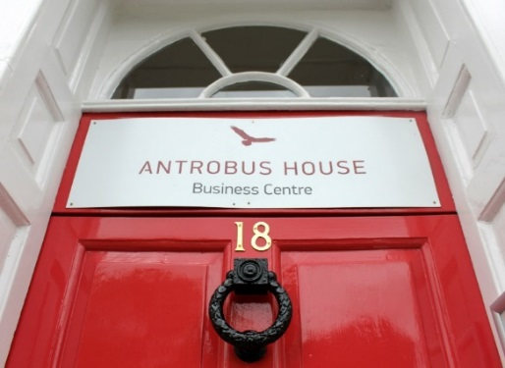

Office Availability May 2019
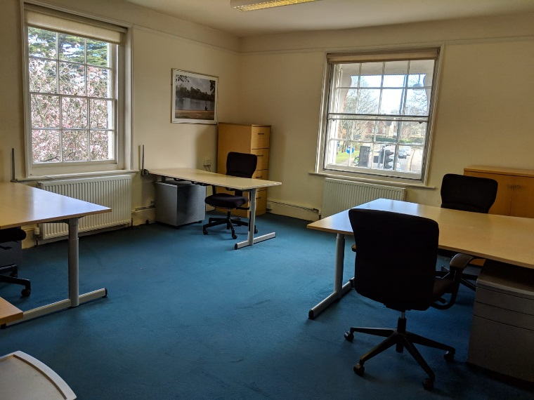
Room 3 – First Floor
Room 3 is on the first floor benefiting from high ceilings, two large sash windows and built in storage units. It can seat up to 3-5 people.
Total area 300 sq feet (27.9 sq m)
2 people £945 + VAT, 3 people £965 + VAT, 4 people £985 + VAT
Desk Hire in a Co-working office
We have one desk available in a co-working office. Perfect for start-ups and freelancers.
This will benefit from all our services, including 24-hour access, free Wi-Fi, use of our address for registered office, cleaning, secure mail box and kitchen facilities with unlimited tea, coffee and milk. (see last page for more details)
£230 +VAT (minimum 1 months’ notice) £215+VAT (minimum 2 months’ notice) £199+ VAT (minimum 3 months’ notice).
Prices quoted are payable monthly in advance via Direct Debit and are based on a minimum 6-month initial contract and are “all-inclusive”.

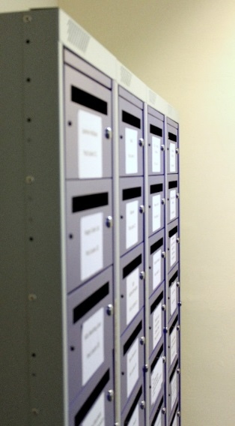
Mail Accommodation
Use our prestigious address for your business or personal mail – stored in secure post lockers, in our dedicated ground floor post room. Post can be collected or forwarded onto you. Our Registered Office service is included.
£35+VAT monthly
Special offer - 12 months for the price of 10 £350 +VAT

About us:
Antrobus House is a Grade II listed building and landmark centrally located in the historic market town of Petersfield, Hampshire. Within 7 minutes’ walk from the train station, which is on the main Portsmouth to Waterloo line. Petersfield is in the beautiful South Downs National Park. We offer flexible, fully serviced office accommodation with initial terms, usually from 1 month to 1 year with flexible notice periods.

Our prices include:

24-hour access, 365 days a year
Broadband (share of a 350MB connection)
Business rates and utilities (water, gas, electricity etc.)
Fully furnished (or bring your own if preferred)
Secure postal locker for incoming mail
Cleaning
A prestigious address
Personal door entry system
Secure shredding facilities
Kitchen (including boiling water dispenser, tea, coffee and milk)
Well-behaved dogs welcome
Chilled, filtered water dispensers
Registered Office (if required)
Available at additional cost
Car Park spaces subject to availability at £70 per month
Landline DDI handsets and dedicated numbers from £5 per month plus modest call charges
Outgoing postal services
High quality printing and photocopying
Faxing and Scanning (receiving and sending)
Dedicated internet connections for very high-volume users

